Reveal Lab 5/2021

**LAB 1 Build a Simple Dashboard in Reveal**

Background: A customer wants to explore a taxi dataset to figure out when and where riders pay the most fares by payment type(credit cards, cash, etc). To explore the data, you as an analyst figure it would be nice to have a Reveal dashboard to show you the data on a map and some controls to filter by time and location as well as a chart to show the total fare cost by payment type. This dashboard will help you explore the data.

1. Setup Custom NYC Dashboard
   1. Prepare Data:
      1. Login into Kinetica gadmin
      2. From the menu bar, select **Data -> Import**
      3. On the right side, click **Advanced CSV Import** button
      4. Click **Select File**
         1. 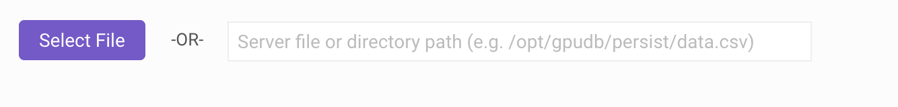
      5. Find demo.nyctaxi.csv on your local machine and select it to be imported
      6. Click **Open**
      7. Click **Import CSV** button at the bottom
         1. 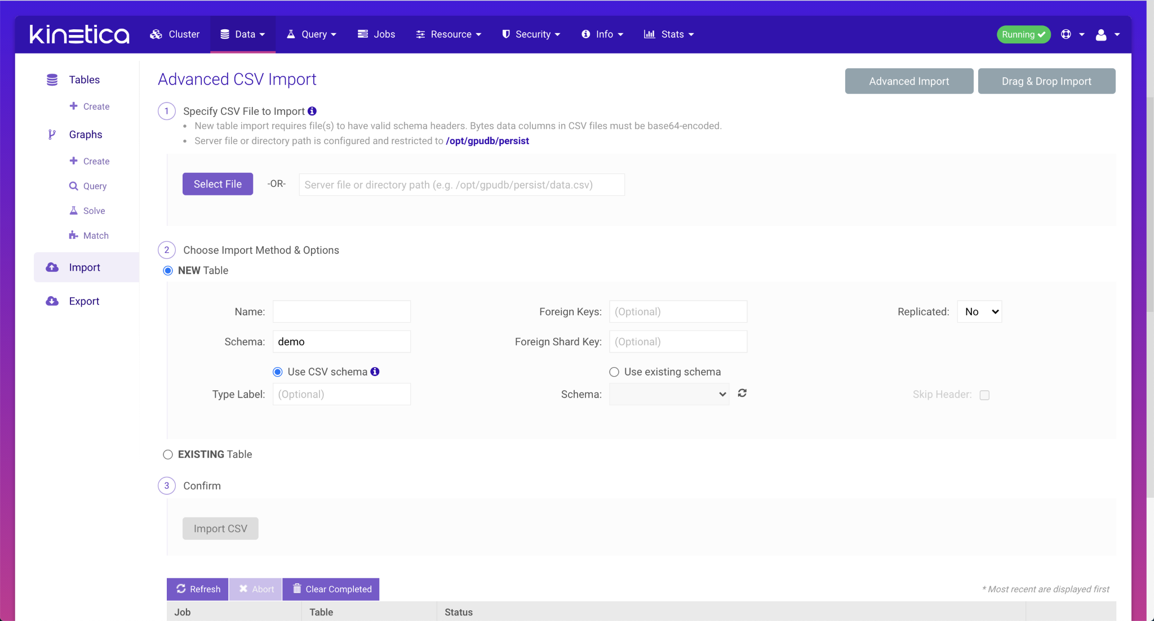
   2. Create NYC Dashboard
      1. Navigate to: [http://<domain>:8088/caravel/connect](http://localhost:8088/caravel/connect)
      2. Login:
         1. User: admin
         2. Password: admin
      3. Connect taxi table:
         1. Select **Sources -> Tables** from top menu bar
            1. 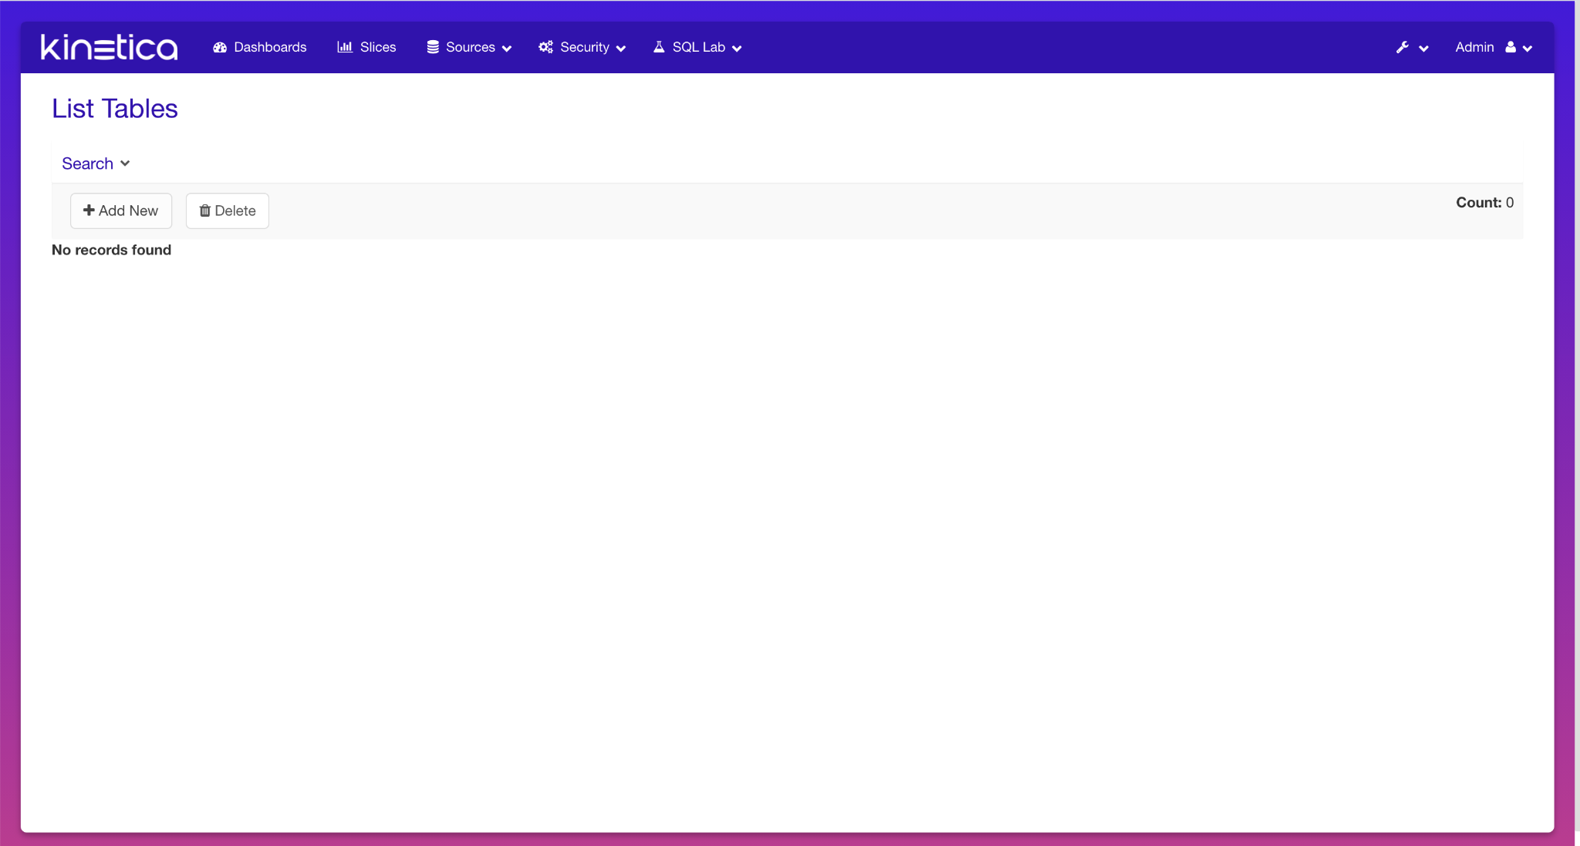
         2. Click **Add New**
         3. Select table **demo.nyctaxi** 
            1. 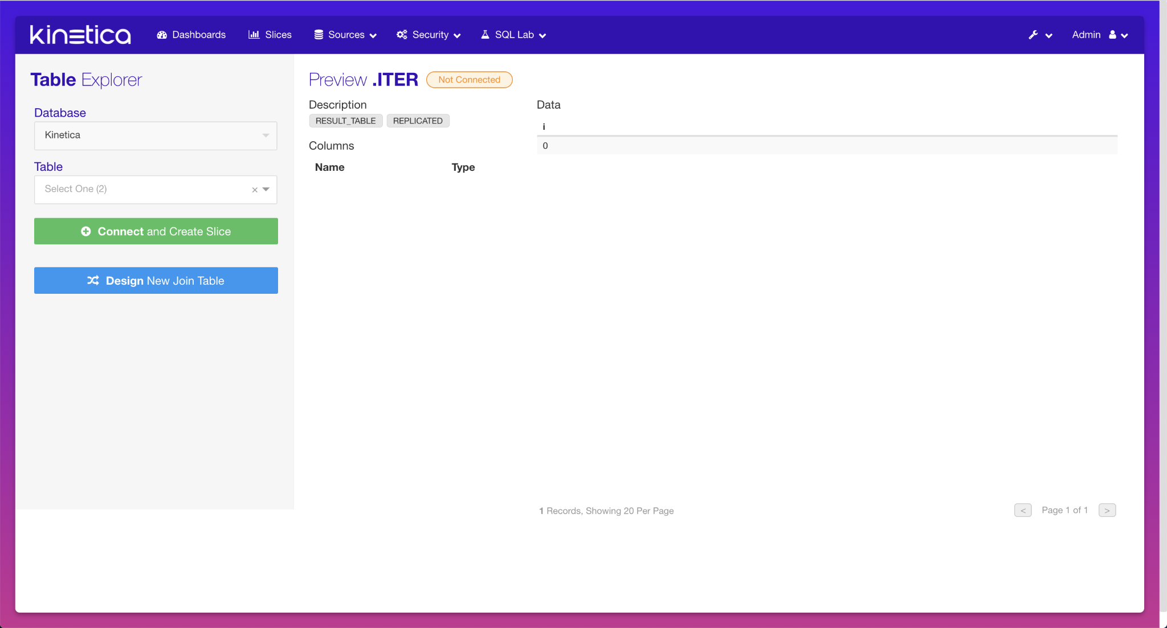
         4. Click **Connect and Create Slice**
         5. Click **OK** on the popup
      4. Create table slice
         1. On the Slice Designer page, make sure **Table** Slice is selected:
            1. 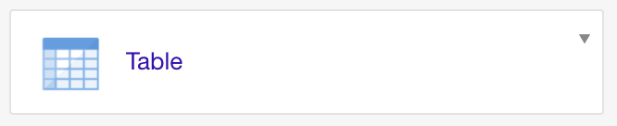
         2. Select **payment_type** for Group by
         3. Select **SUM(fare_amount)** for Metrics
         4. Click **Update**
            1. 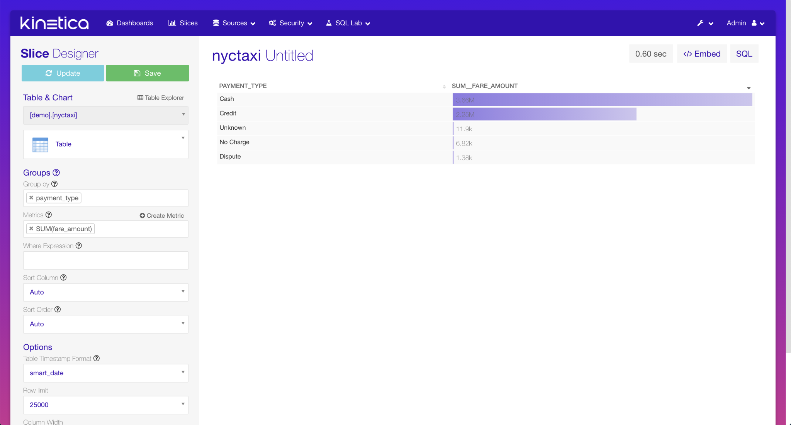
         5. Click **Save**
         6. In the Dialog
            1. Enter **Total Amount** in the Save as field
            2. Select **Add to new** radio button under Dashboard and enter **NYC Dashboard**
            3. Click **Save & Go To Dashboard**
            4. 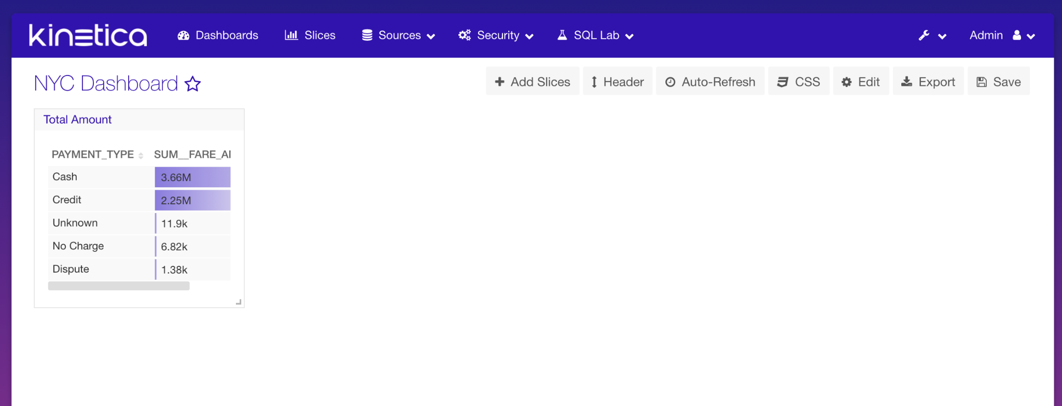
      5. Add a Filter slice:
         1. From the dashboard, click **Add Slices**
            1. Click **Create New Slice**
            2. Click **Create Slice With Table**
            3. Click **Table**(from Table & Chart), and select **Filter**

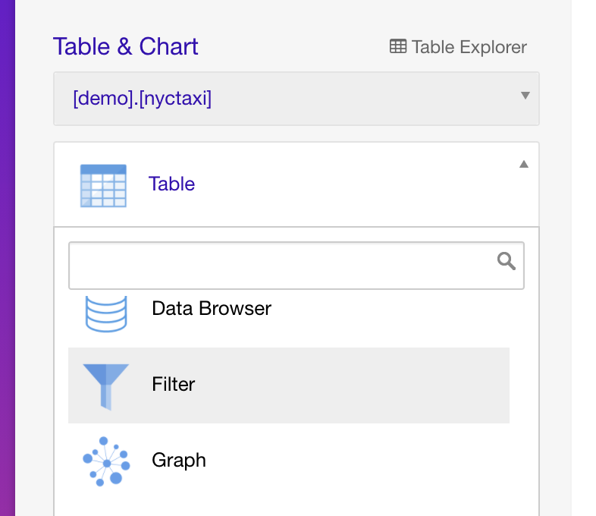

* + - * 1. Select **pickup_datetime** for Time Column
        2. Uncheck **Enable Time Range Search**
        3. Uncheck **Enable Text Search**(this table does not have any text enabled columns)
        4. Change the color theme, by entering **gnbu** for Default Theme

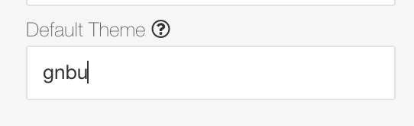

* + - * 1. Click **Update** and verify the slice looks like this:

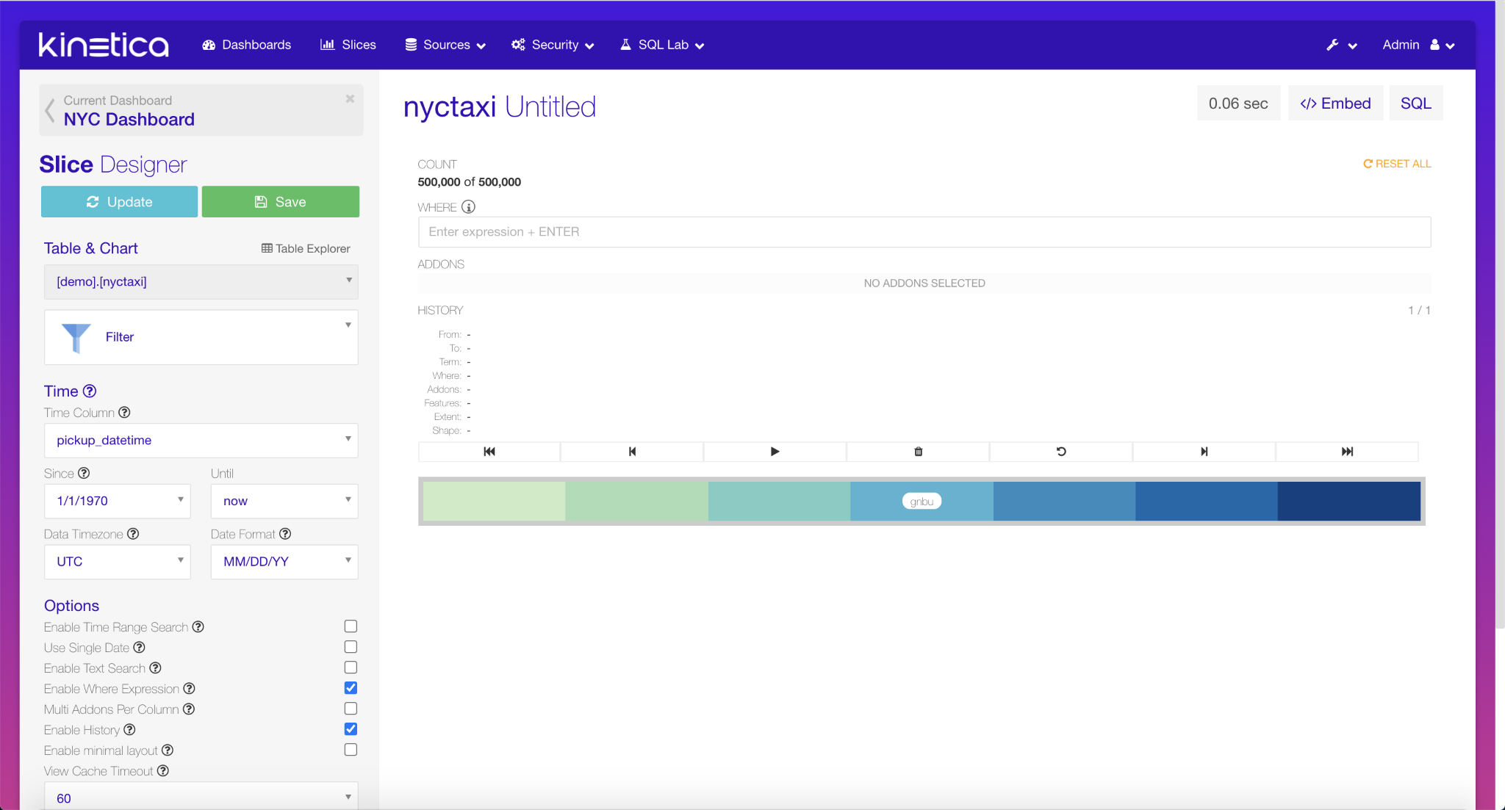

* + - * 1. Click **Save**
        2. On the Dialog

For Save as, enter **NYC Taxi Filter**

Click the **Add to existing** radio button and make sure the **NYC Dashboard** is selected

Click **Save**

* + 1. Add a Map Slice
       1. Click **Filter** under Table & Chart and select **Map**
          1. 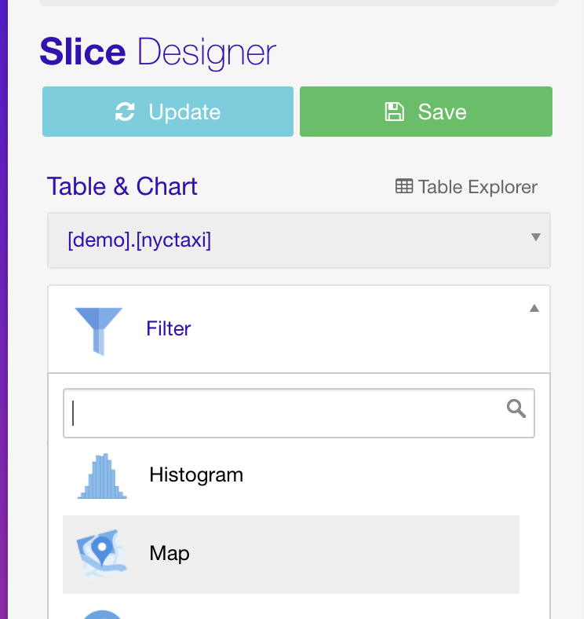
       2. Make sure **pickup_datetime** is selected for Time Column
       3. Select **pickup_longitude** for Longtitude
       4. Select **pickup_latitude** for Latitude
       5. In the Popup Template type:
          1. **Company: [vendor_id] <br/>**

**Payment Type: [payment_type] <br/>**

**Taxi Fare: [fare_amount] <br/>**

**Taxi Tip: [tip_amount] <br/>**

* + - 1. Click **Update**
      2. Click on the taxi data on the map after the page reloads and you should see a popup that looks similar to the screenshot below
         1. 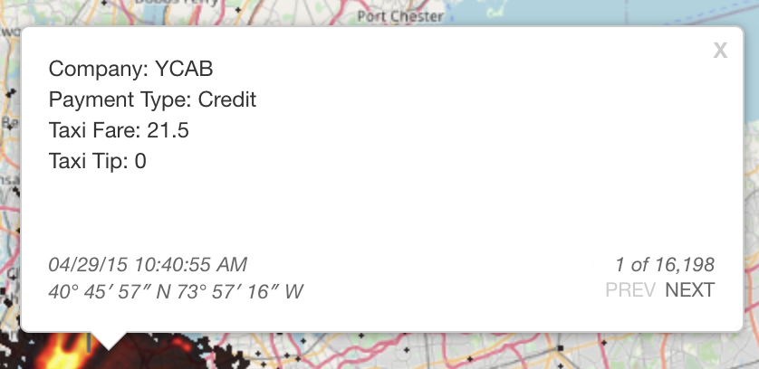
      3. Click **Save**
      4. On the Dialog
         1. Click the **Save as** radio button and enter **NYC Taxi Map**
         2. Click the **Add to existing** and select **NYC Dashboard**
         3. Click **Save**

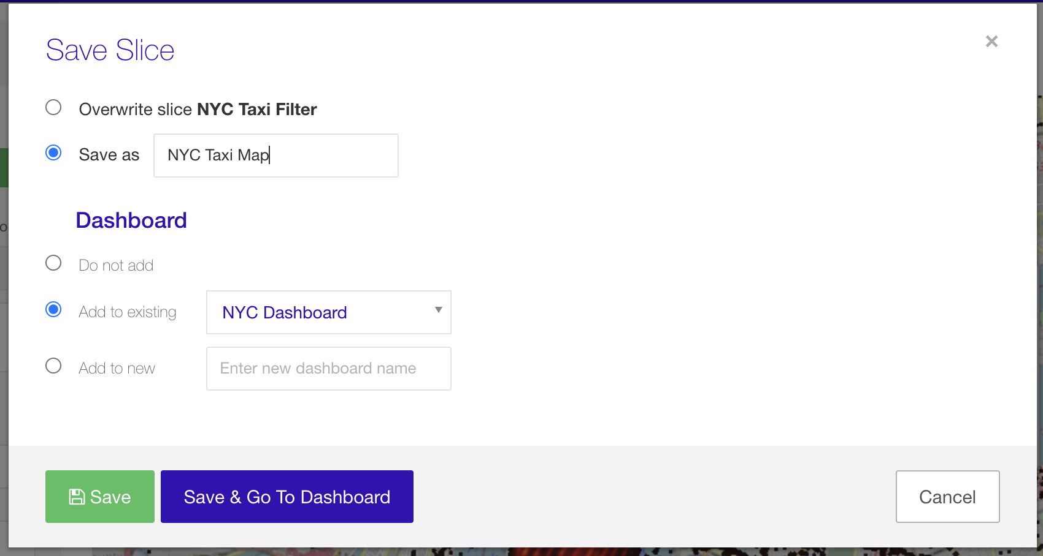

* + 1. Add a timeline slice
       1. Click **Map** and select **Time Series Line**
          1. 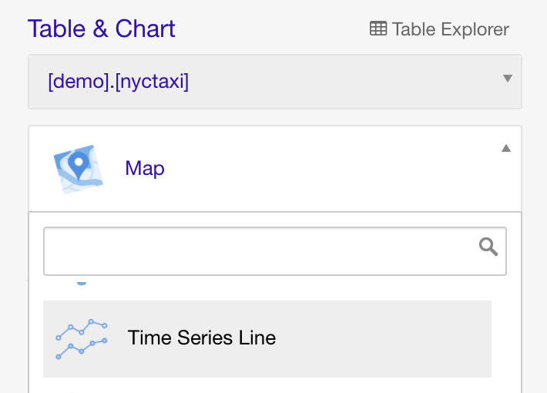
       2. Select **SUM(fare_amount)** for metrics
       3. Click **Save**
       4. On the Dialog
          1. Click the **Save as** radio button and enter **NYC Taxi Timeline**
          2. Click the **Add to existing** and select **NYC Dashboard**
          3. Click **Save & Go To Dashboard**
          4. 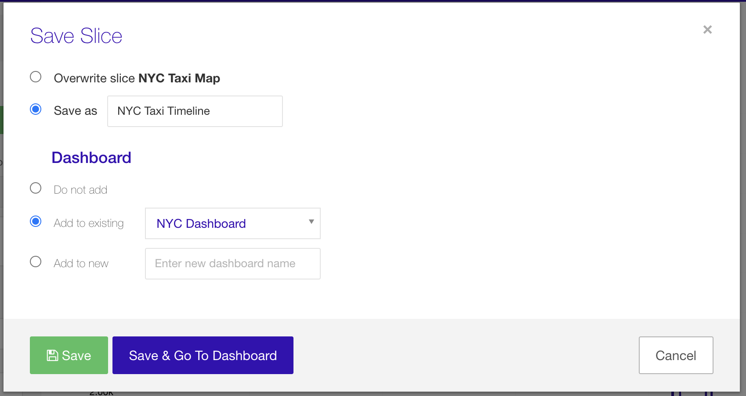
    2. Arrange the slices on the Dashboard
       1. Click the **Header** button on the top right corner to show the headers over each slice
       2. Click and drag the **Move** icon to arrange slices
          1. 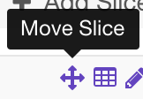
       3. Click and drag the resize tick on the bottom right corner of each slice to size each slice
       4. Now arrange the slices so the dashboard looks like this:
          1. 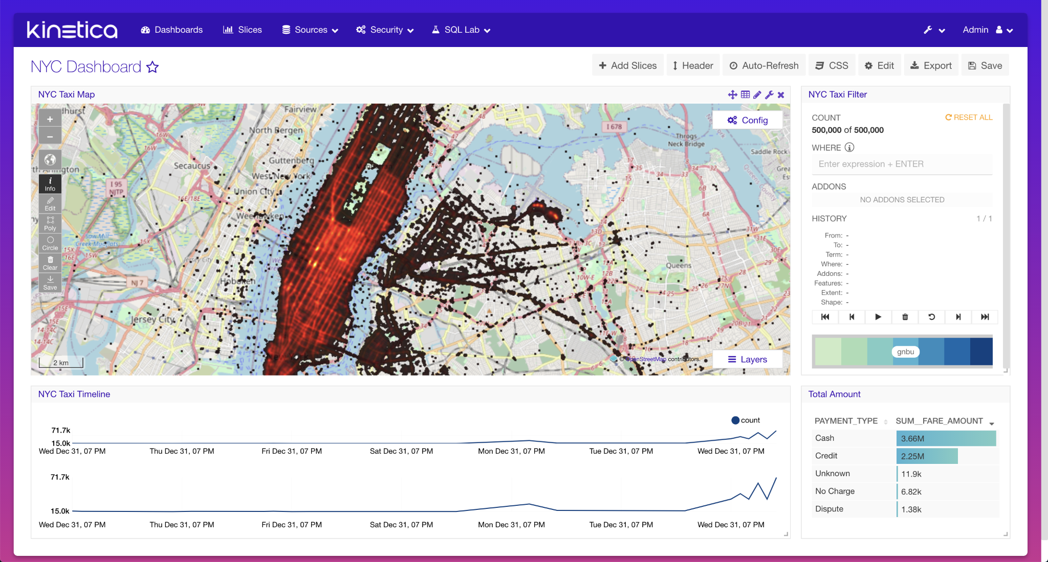
       5. Click the **Save** button on the top right corner to save the dashboard in its current state.

**LAB 2 Customizing Reveal**

Background: The customer was happy with the dashboard but would like to see an additional chart showing the tip percentage by cab company to see if there is any relationship. The customer would also like to show the dashboard to his customers so that they can explore the data but would like it to use his company's color theme and logo.

1. Select **Sources -> Tables**(top menu bar)
2. Click the pencil icon to edit table
   1. 
3. Click **List SQL Metric** tab, if it is not already selected
4. Click **Add New**
5. Create Metric
   1. Enter **avg_tip_percent** fore Metric
   2. Enter **avg_tip_percent** for Verbose Name
   3. Enter **avg** for Type
   4. Enter **AVG((tip_amount/fare_amount) * 100)** for SQL Expression
   5. Select **nyctaxi** for table
   6. Click **Save**
6. Create new slice using the new metric
   1. Click **Slices** from the menu bar
   2. Click **Add New**
   3. Make sure **demo.nyctaxi** is selected for table
   4. Click **Create Slice With Table**
   5. Make sure Table Slice is selected:
      1. 
   6. Select **vendor_id** for Group by
   7. Select **AVG((tip_amount/fare_amount) * 100)** for Metrics
   8. Click **Update**
   9. Click **Save**
   10. On the Dialog
       1. Enter **Taxi Tip Percent**
       2. Click **Add to existing** radio button and select **NYC Dashboard**
       3. Click **Save & Go To Dashboard**
          1. 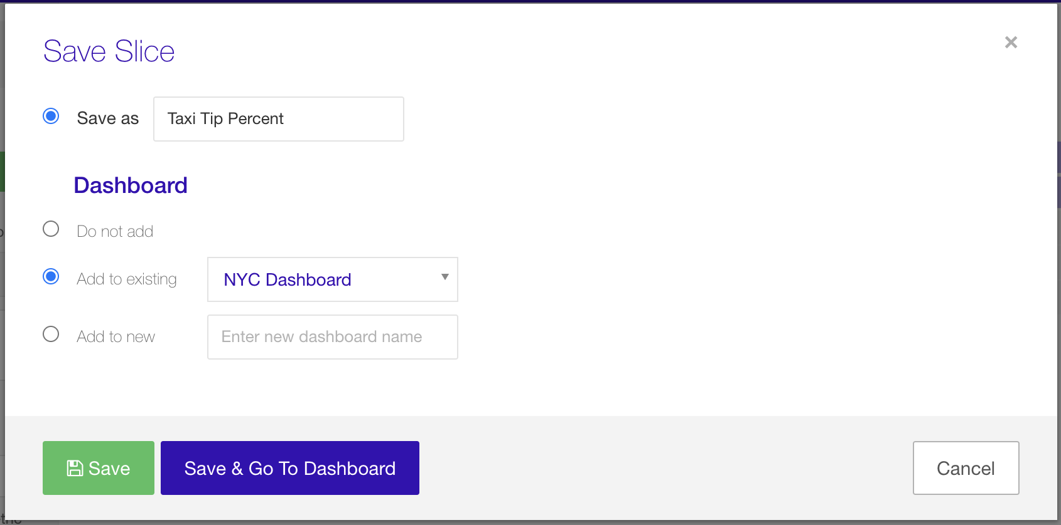
   11. On the NYC Dashboard arrange the slices so it looks like the dashboard below:
       1. 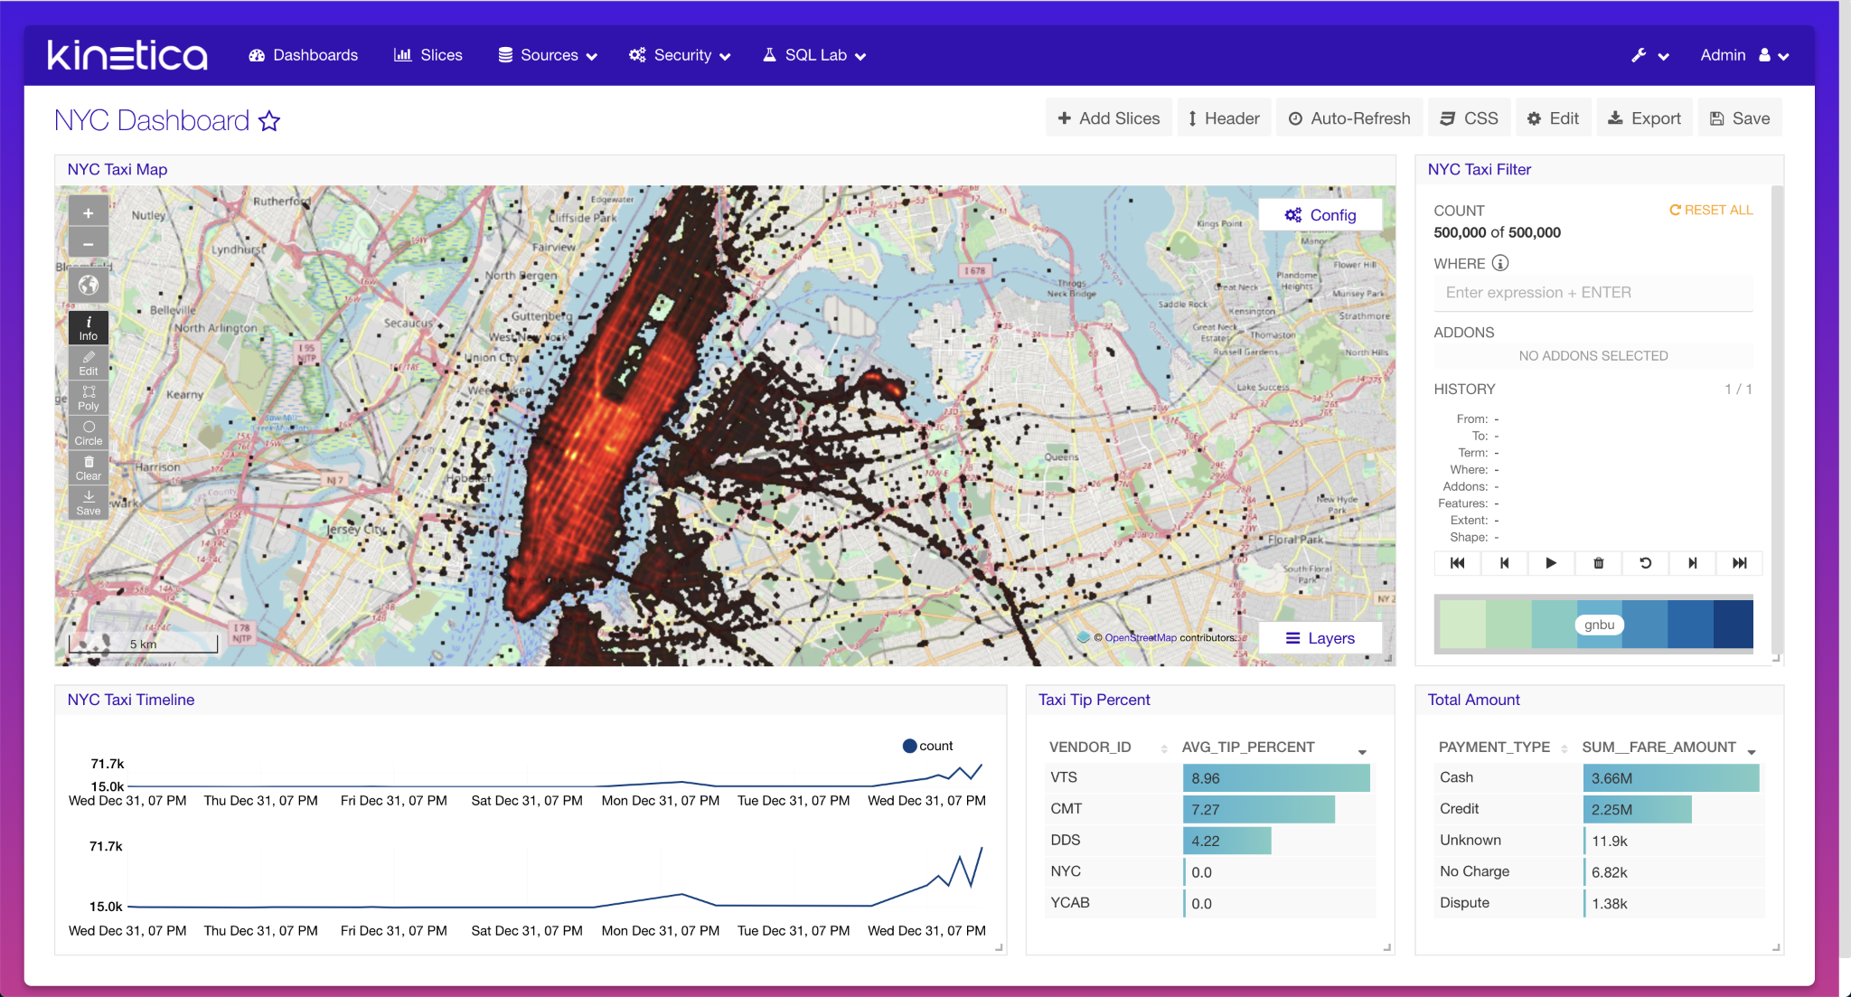
   12. Click **Save**
7. Use the Dark Theme
   1. Click the **CSS** button
   2. On the Dialog
      1. Change the CSS Template drop down to **Dark Theme**
      2. Add the following text to the bottom of the css to make dashboard name a little larger
      3. h3 { font-size: 40px !important; }
      4. 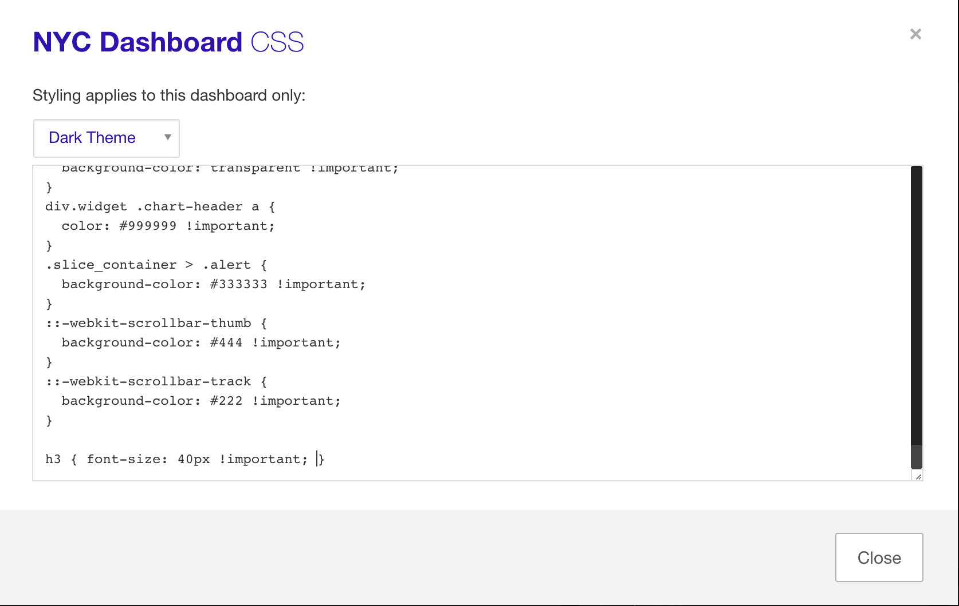
      5. Click **Close**
      6. Click the **Save** button
8. White labeling Reveal
   1. Click the wrench icon on the top right corner of Reveal
      1. 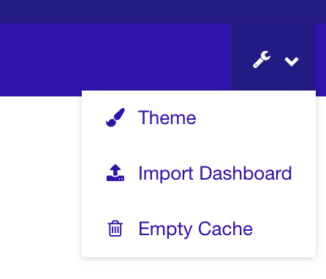
   2. Select **Theme**
   3. Click the Kinetica Brand logo and Upload the **Relaxi Taxi.png** to change the application icon
   4. Change the Primary Color to **#084181**
   5. Change the Secondary Color to **#4eb4d2**
   6. Change the Tertiary Color to **#ccebc5**
   7. Change the Background Start Color to **#4eb4d2**
   8. Change the (second) Background Start Color to **#ccebc5**
   9. 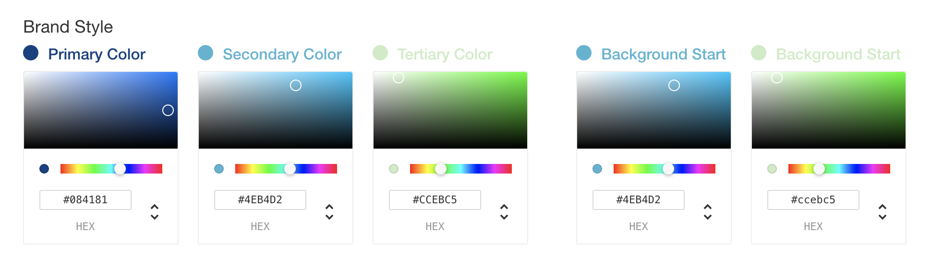
   10. Click **Update Style**

**LAB 3 Developing a custom slice using Reveal SDK**

Background: The customer wants one more custom chart that shows the total fare amount in blue text. You decide to create a custom slice to do this in case the customer decides they want to customize this slice even more

1. Install the SDK
   1. Follow steps here: https://docs.kinetica.com/7.1/analytics/reveal/sdk/index.html
      1. Run: **ssh <user>@devnode**
      2. Install git(use the installation for your OS: https://git-scm.com/download/linux)
         1. Example: “yum install git”
      3. Run: **export PATH=/opt/gpudb/connectors/reveal/bin:$PATH**
      4. Install Reveal SDK
         1. Run: **npm install -g /opt/gpudb/connectors/reveal/sdk**
2. Create custom slice
   1. From the terminal create a directory to save your slices in
      1. Run: **mkdir /opt/reveal_dev**
   2. Create slice
      1. Run: **reveal-sdk slice-create /opt/reveal_dev/**
      2. Use the following entries for the prompts:
         1. What is the slice name?
            1. **custom_slice**
         2. Who is the author?
            1. **Kinetica Developer**
         3. What is the display name?
            1. **custom_slice**
         4. What is the slice description?
            1. **Lab work**
      3. Open a new session to the same machine
         1. Run: **ssh <user>@devnode**
      4. In the new session start the slice watch
         1. Add the Reveal SDK to your path for the new session
            1. Run: **export PATH=/opt/gpudb/connectors/reveal/bin:$PATH**
         2. Prior to starting the slice watch move the package-lock.json file since it is not in sync with the node_modules
            1. Run: **cd /opt/gpudb/connectors/reveal/lib/python2.7/site-packages/caravel-0.11.0-py2.7.egg/caravel/static/assets**
            2. Run: **mv package-lock.json package-lock.json.old**
         3. Run: **reveal-sdk slice-watch /opt/reveal_dev/custom_slice**
      5. Open the new slice
         1. On the browser, open Reveal
         2. Click **Slices**, on the menu bar
         3. Click **Add New**
         4. Click **Create Slice With Table**
         5. For chart, select **custom_slice**
            1. 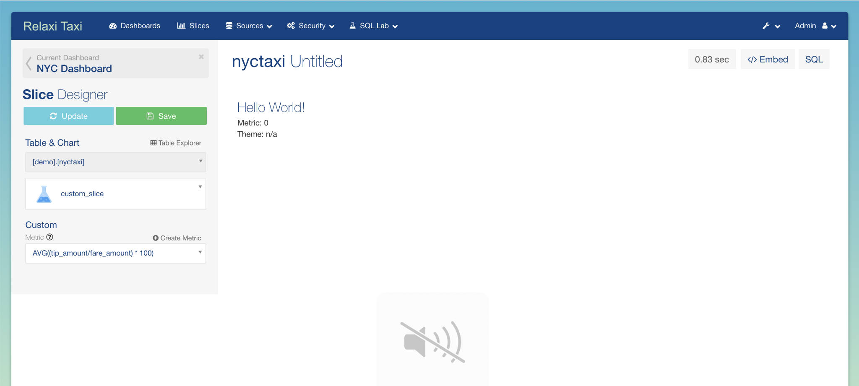
         6. For metric, select **SUM(fare_amount)**
         7. Click **Update**
            1. 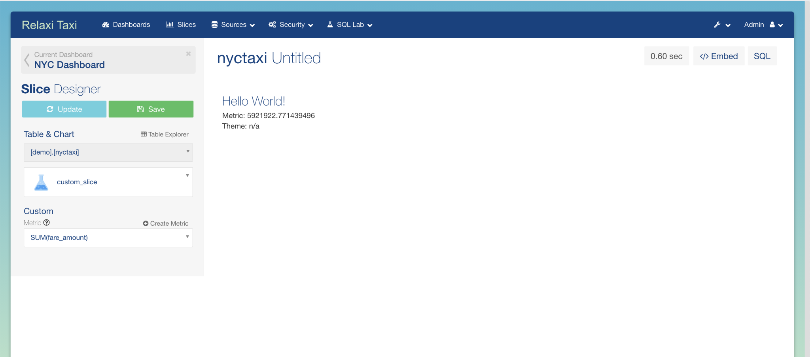
      6. Modify the new slice and watch the slice update
         1. Edit file using command line:
            1. (Option 1) Command Line:

At the terminal not running the slice watch

Run: **vi /opt/reveal_dev/custom_slice/viz.js**

* + - * 1. (Option 2) Visual studio or IDE:

Connect to the Kinetica machine from your IDE

Open file /opt/reveal_dev/custom_slice/viz.js

* + - 1. Edit viz.js
         1. Round the metric:

Replace:

**const metric = data[0][0];**

with

**const metric = data[0][0] != null ? Math.round(data[0][0]) : data[0][0];**

* + - * 1. Edit the HTML:

Replace:

**div**

**.append('div')**

**.html(**

**`<h3>Hello World!</h3>Metric: ${metric}<br />Theme: ${theme ||**

**'n/a'}`**

**);**

With

**div**

**.append('div')**

**.html(**

**`<h4 style="color: lightblue !important;">Total Amount: ${metric}</h4>`**

**);**

* + - 1. Save the file
    1. Clear cache and refresh the Reveal page to see the changes. The amount should now be rounded.
       1. 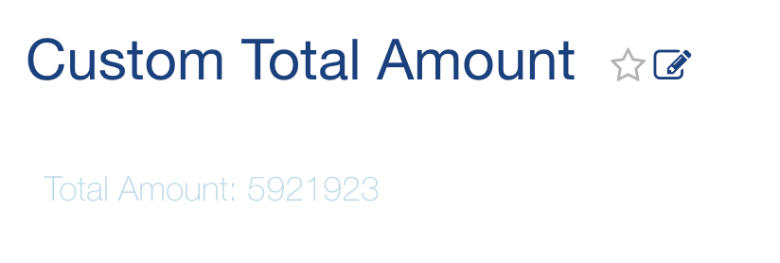
    2. Click **Save** on the Slice Designer
    3. In the Dialog
       1. Enter **Custom Total Amount** in the Save as field
       2. Select **Add to existing** radio and select **NYC Dashboard**
       3. Click **Save & Go To Dashboard**
    4. On the Dashboard
       1. Rearrange the slices to resemble the image below:
          1. 